Website operation manual:

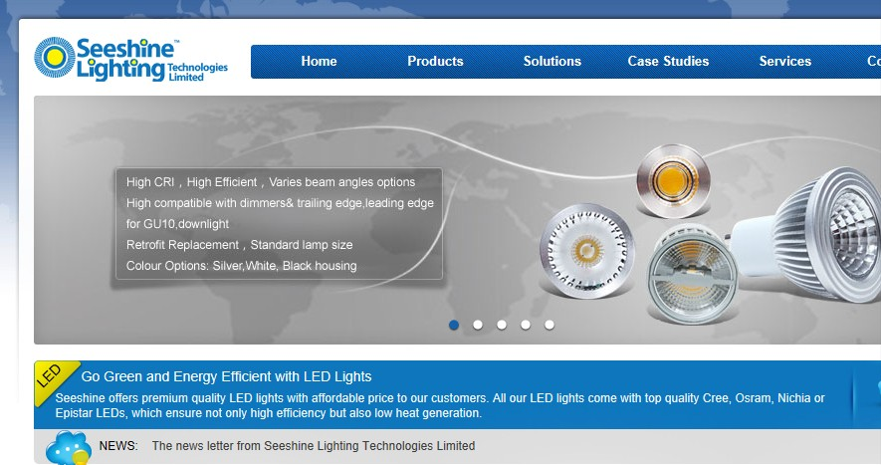
In this page, you can see there is 5 bottom which is for reviewing the products advertisement. By click the round bottom to switch to another page.
This is a quick menu to review the recent product/industry/Industry/company news that been featured.
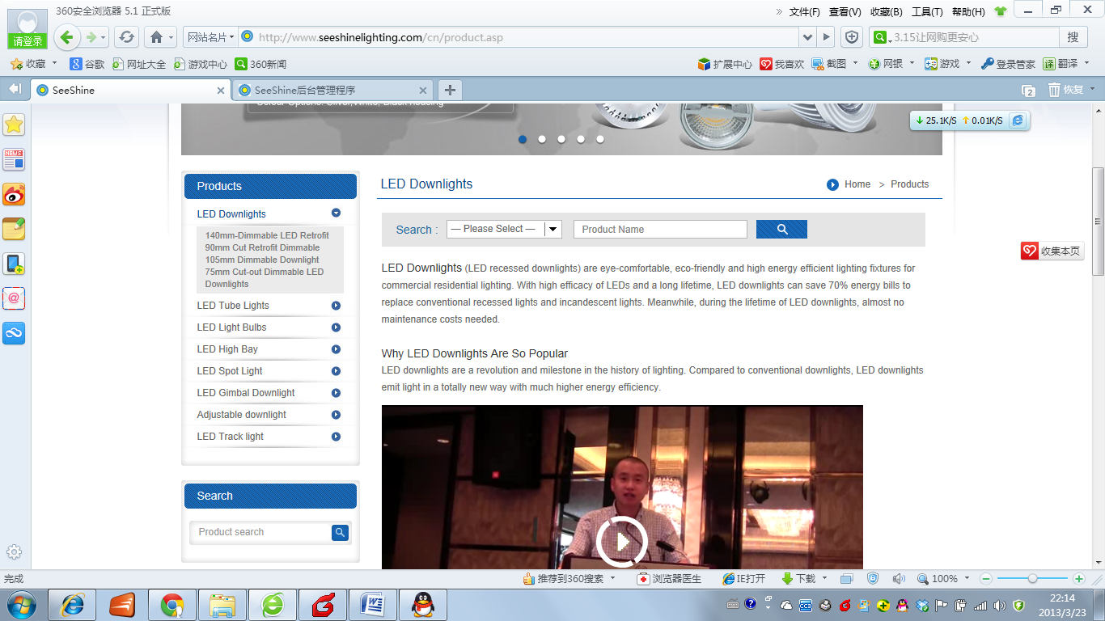
This is product index page,
Brief introduction of one product category and its video.
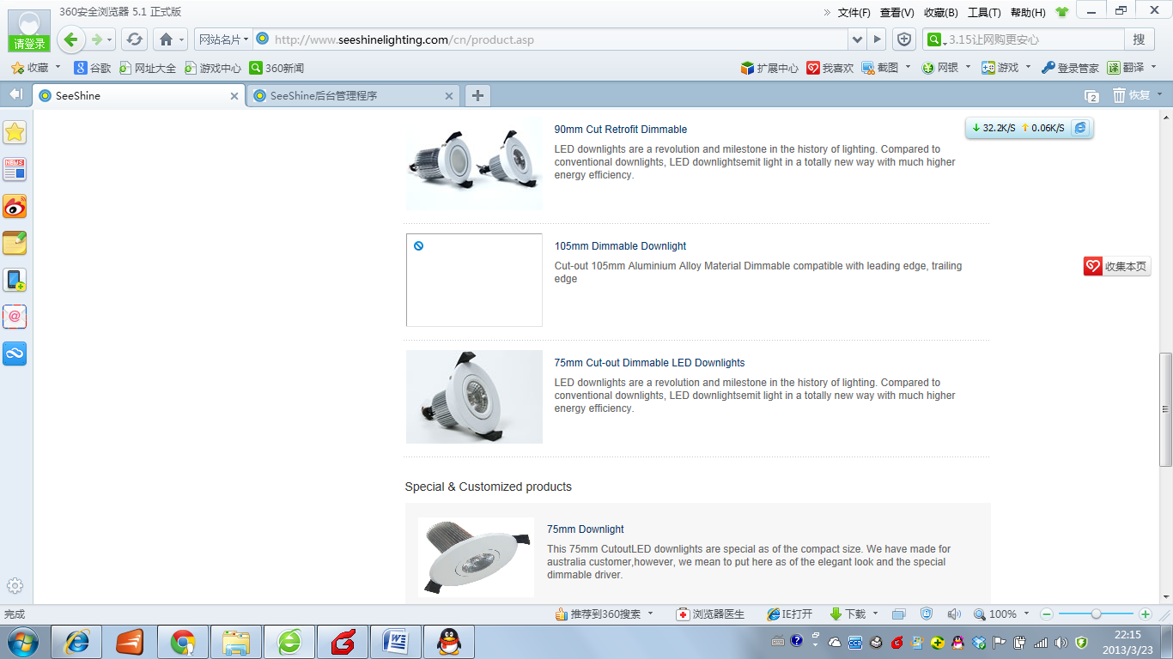

Scroll down to review more products that are under this category.
In the middle of the page, it is the special & customized products. By clicking the picture, there will be listing on the product specification download page.
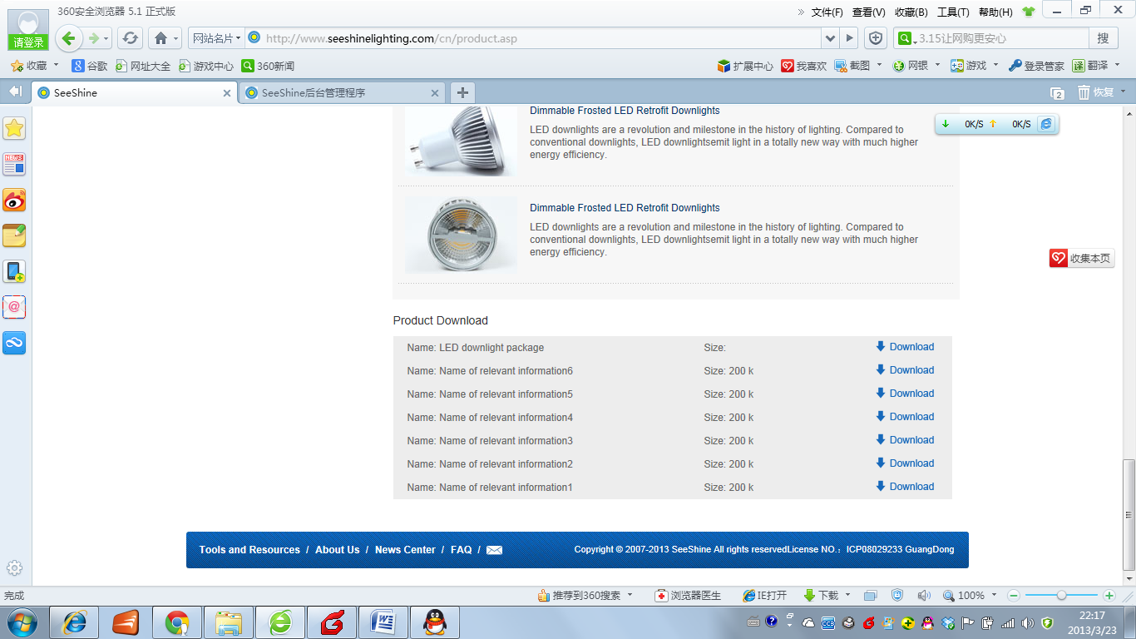
Product download
It is a place to download the whole product category(Example Downlight VS LED bulb) certifications, Package information that share same informations.

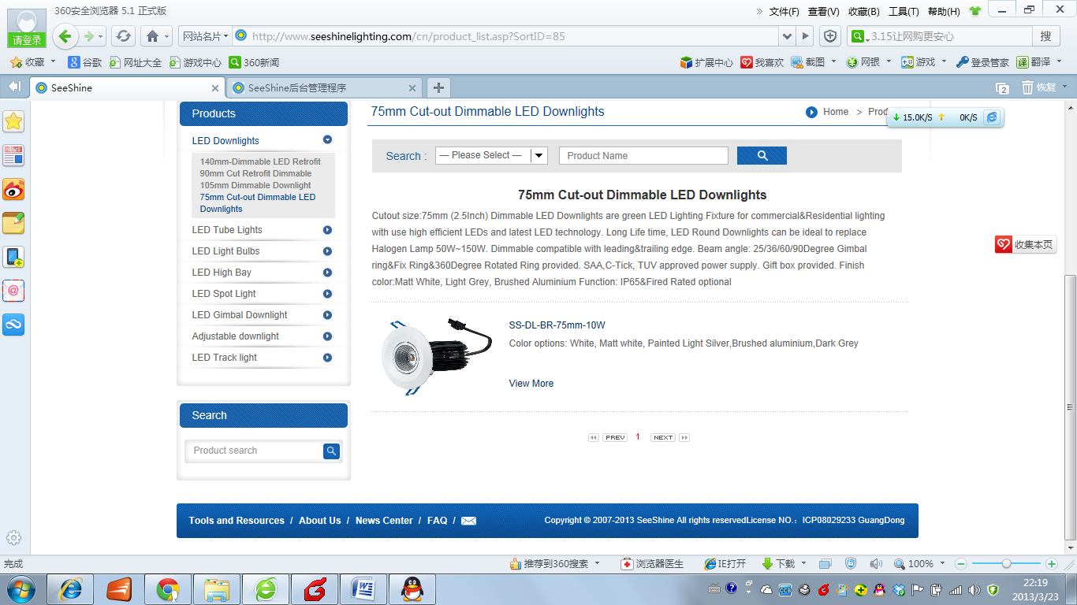
This is a brief instroduction of the divided product(Example 75mm cut-out downlight features under downlight category)

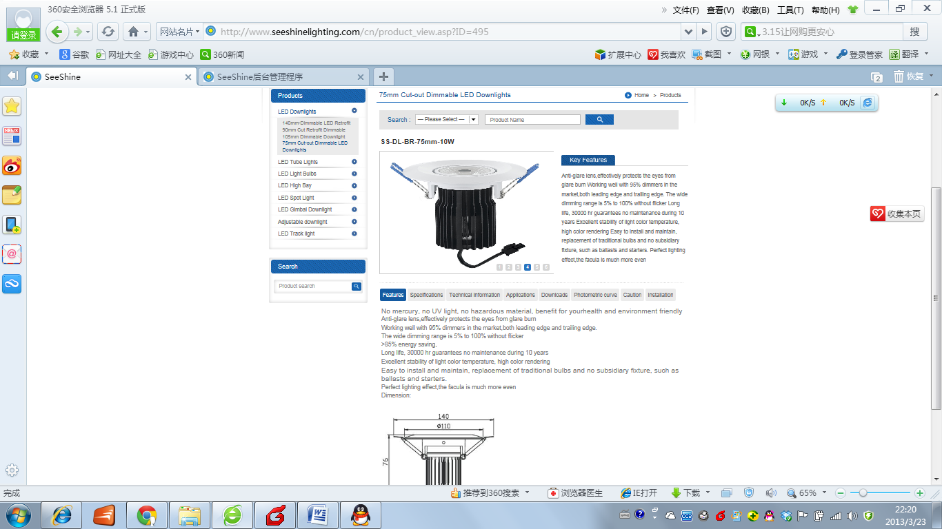This is the product main page that give spec, technical information, IES File, installation…etc.
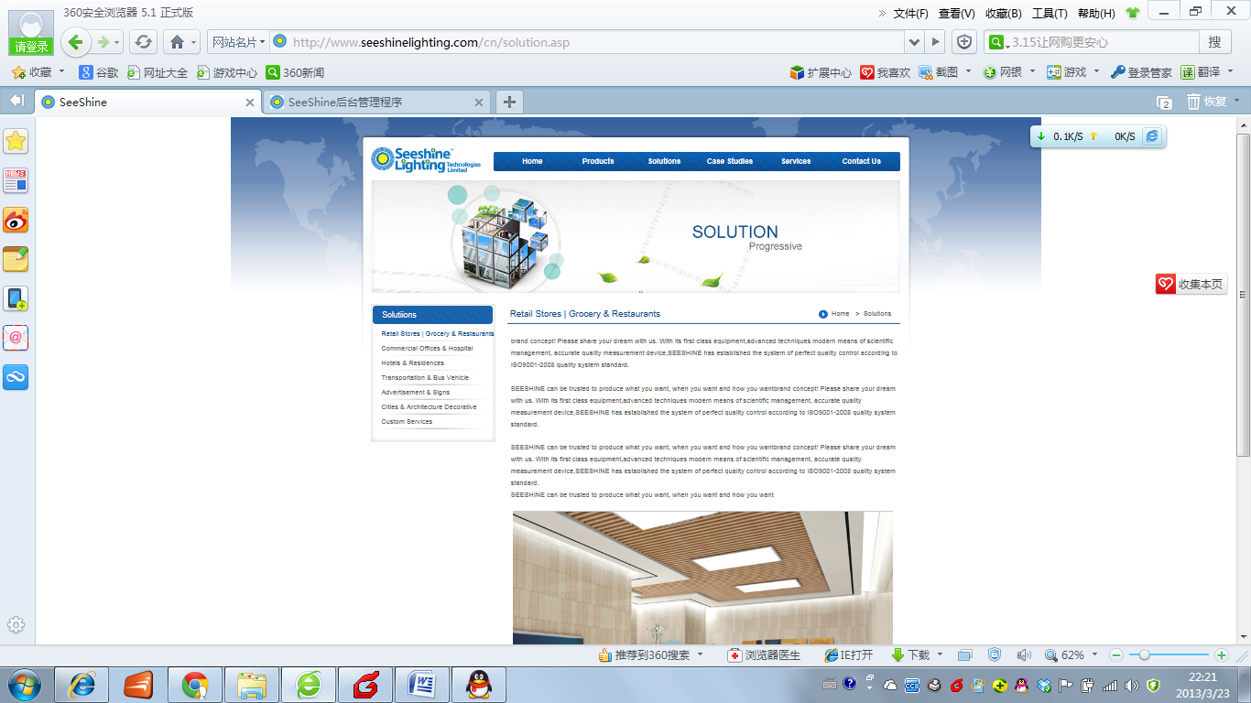Solution center is that solution that we give for our customer and feature some here.
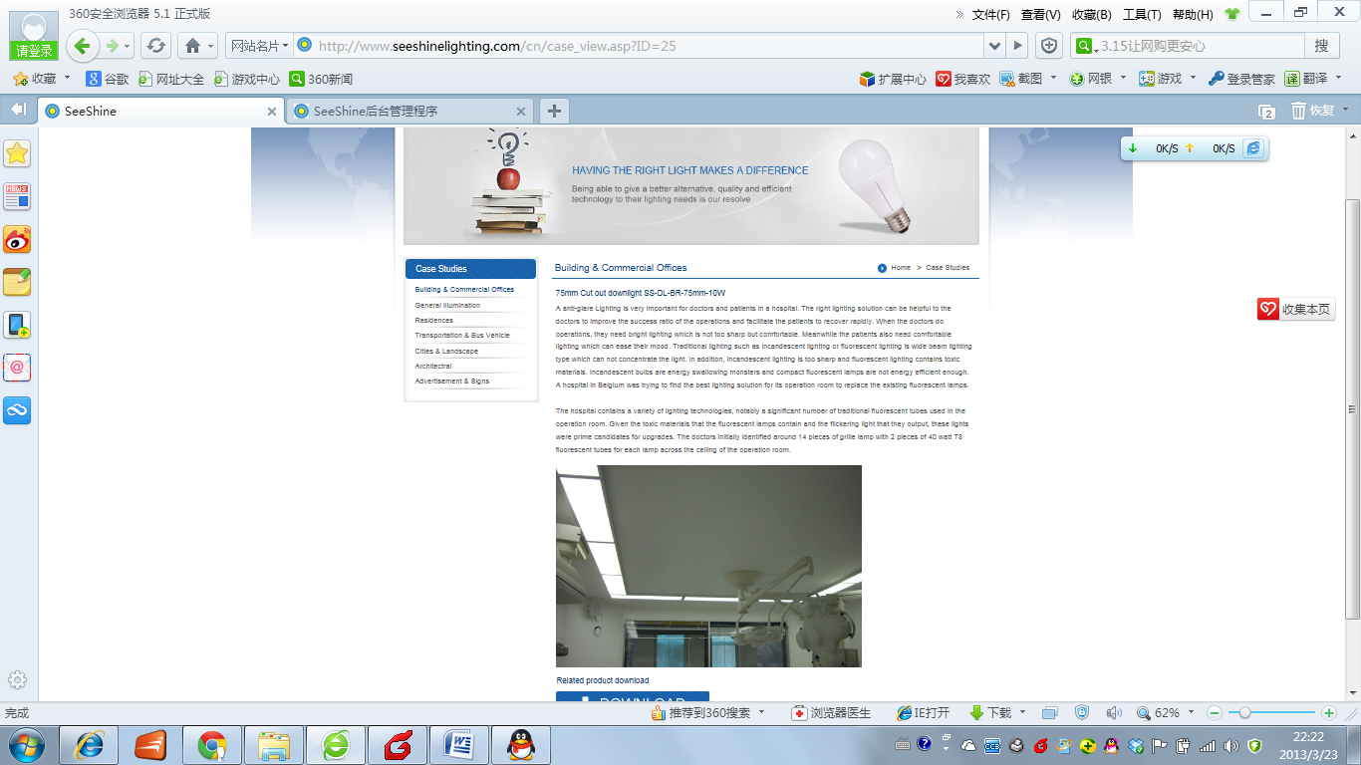
Case studies is the case that for two~ five products that we list a case here to share.
There is a download menu that allow download the whole project and the lighting that being used.
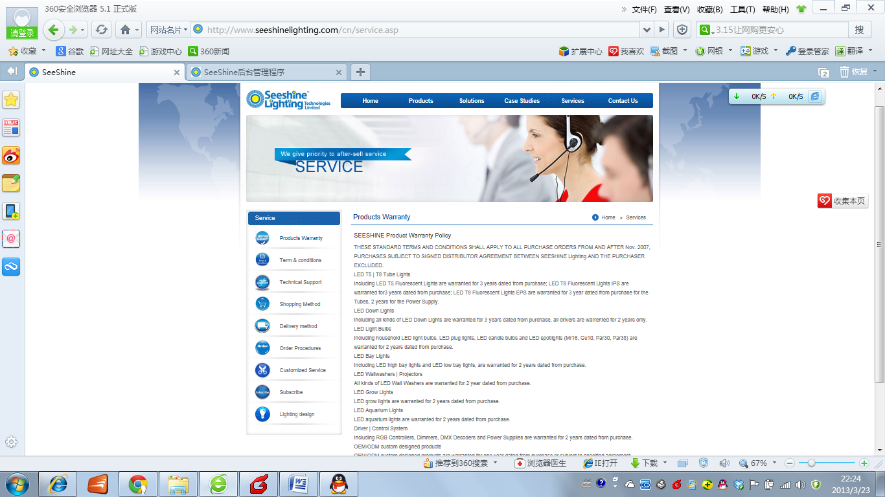
Product Warranty, Term&Conditions

Lighting Design
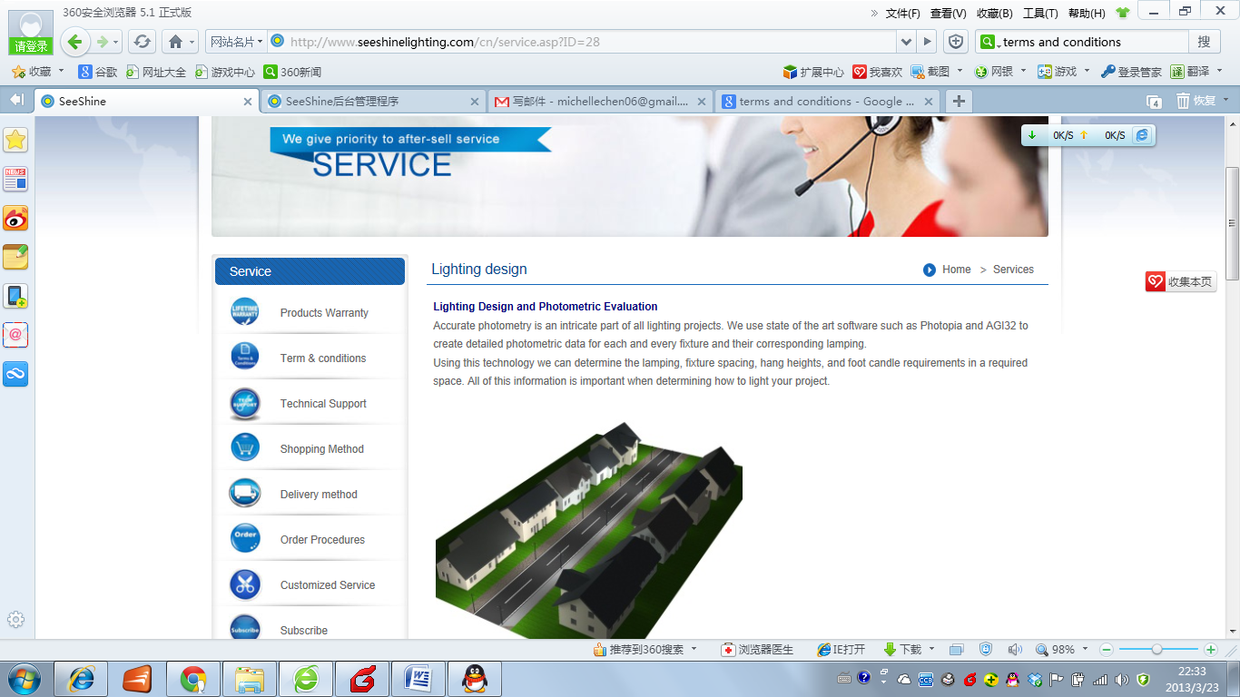

Tools and resources: Product datasheet,IES Files,Energy caculater, shipment tracking, Installtion, User’s manual.
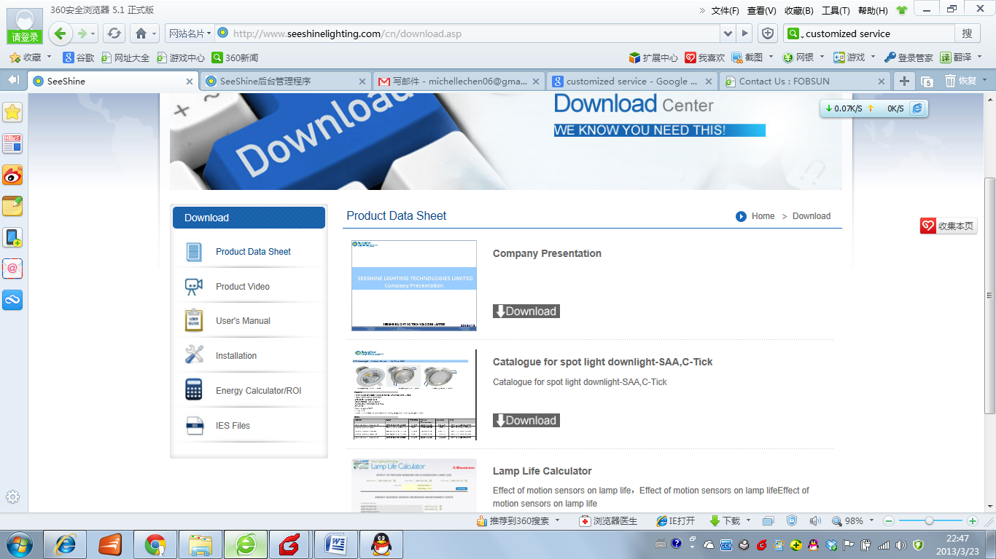

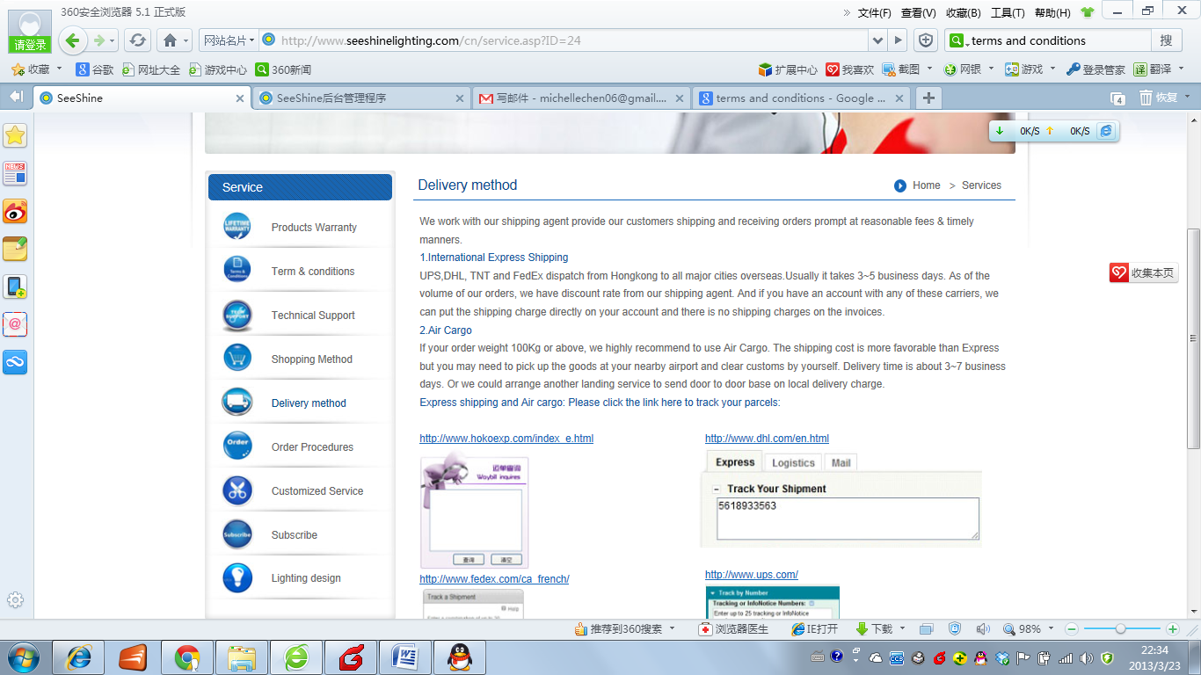
Delivery method

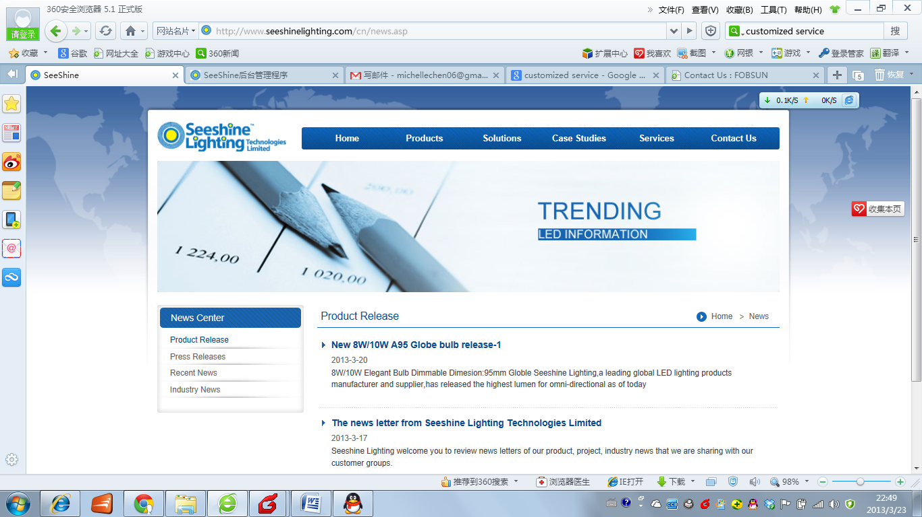
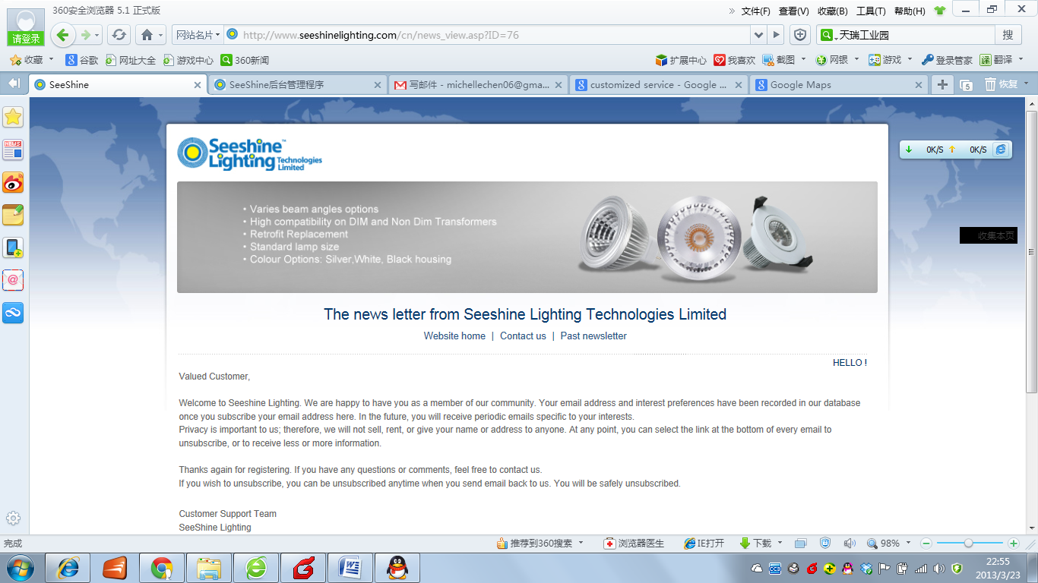
News center,
Here we would release product/featured project industry news and press news, exhibition information . You can always go back by click the “home” bottom. Or you can subscribe here we would send the news to your email box directly.

